VON DIGITALIS ESTATES

Integrated Digital Estate Architecture
Architecture Kata 2026 | Final Submission
ARCHITECTURE THESIS A resilient, event-driven digital estate connects visitor growth, crowd operations, ride reliability and animal welfare through governed domain boundaries, edge-first telemetry and a shared data and AI platform. Deterministic controls and accountable people retain authority for safety, welfare, commerce and operational decisions.

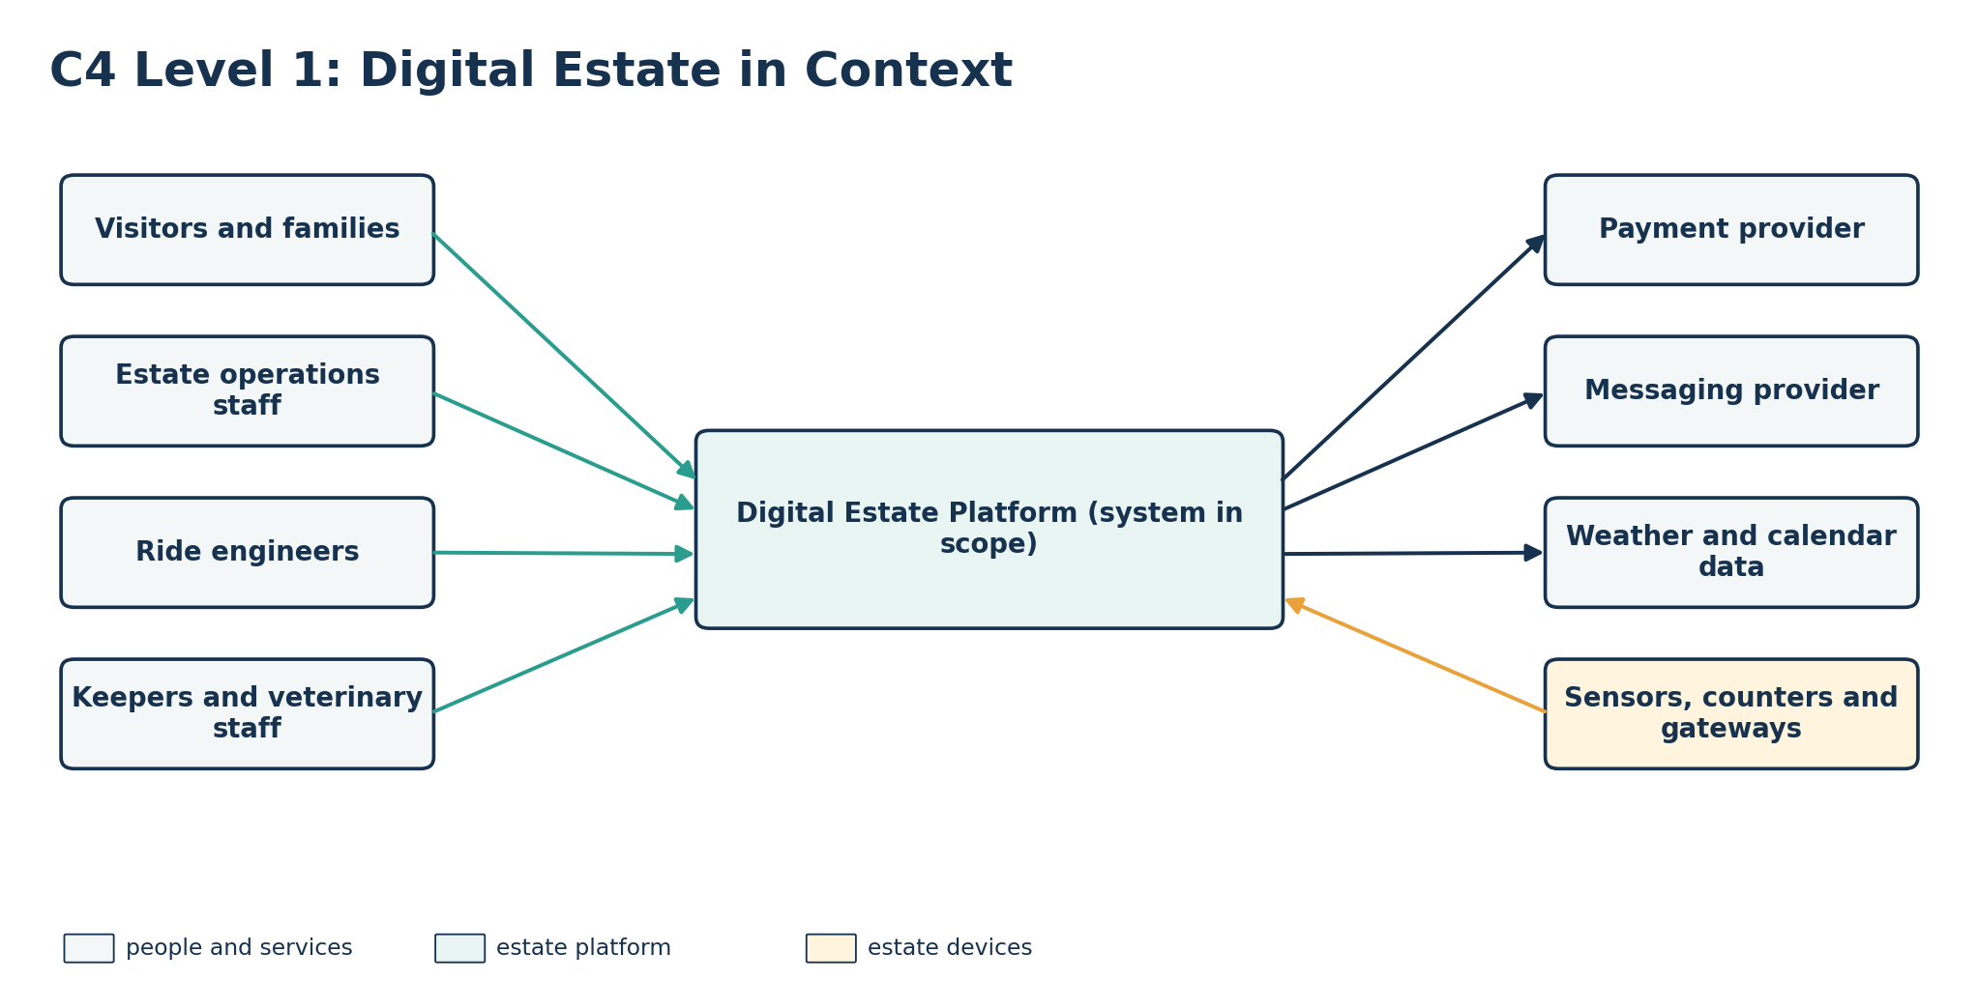
Figure 1. C4 Level 1 context. The estate platform connects people, operational devices and external services.
Decision-led | Outcome-traceable | AI-enabled with explicit guardrails

1. Executive summary
Von Digitalis Estates must support growth from approximately 5,000 to at least 15,000 visitors per day within three years while improving profitability, ride reliability and animal welfare. The estate includes 40 historically important rides and more than 200 animals across 55 displays and enclosures. Patchy Wi-Fi means the architecture cannot assume continuous cloud connectivity.
The proposal is organised around four business capabilities: Visitor Journey & Growth, Crowd & Site Operations, Ride Operations & Asset Reliability, and Animal Care & Welfare. Each capability owns its authoritative records. A shared event platform distributes curated facts, while a governed data and AI platform supports analytics, forecasting and evidence-backed recommendations.
FIVE SHAPING DECISIONS 1) domain-owned systems of record; 2) event-driven integration; 3) edge-first MQTT ingestion with store-and-forward; 4) deterministic safety, welfare and commercial controls; 5) provider-neutral AI behind policy and accountable human decisions.

Business outcomes
Outcome | Architecture response | Evidence of success
Profitable visitor growth | Reliable ticketing and family passes; consent-led engagement; controlled experiments | Purchase availability; repeat-visit and referral uplift; campaign contribution
Better visitor flow | Anonymous sensing; confidence-rated queue estimates; approved guidance | Queue accuracy and freshness; congestion trend; guidance uptake
Reliable rides | Authoritative inspections and maintenance; local controls; predictive recommendations | Availability; unplanned downtime; warning lead time
Healthy animals | Digital care workflows; local alarms; anomaly recommendations | Alert latency; task completion; preventable incidents
Resilient operations | Zoned gateways; buffering; replay; stale-data handling | Telemetry durability; recovery tests; device-health ownership

Accepted trade-offs
Decision | Deliberately accepted consequence
Domain ownership and events | Eventual consistency in exchange for clear accountability and independent change
Edge-first collection | Managed hardware and reconciliation effort in exchange for outage resilience
Human accountability | Lower autonomy in exchange for safer welfare, engineering and commercial decisions
Privacy-minimised sensing | Less individual-level insight in exchange for lower privacy risk
Provider-neutral AI | Additional abstraction and compatibility testing in exchange for model and provider replaceability

Constraints, assumptions and unknowns
- MQTT transports telemetry and events; it is not a system of record.
- Existing ride interlocks and enclosure life-support controls remain local, deterministic and independent.
- Operational domains publish minimum-necessary events rather than unrestricted records.
- Numerical targets are proposed starting points and require validation during discovery.
- Legacy rides will vary in telemetry feasibility; instrumentation must not interfere with certified controls.
- Useful AI depends on trustworthy historical and outcome data that may not initially exist.
- The collection operates under zoo licensing and association accreditation. Licensing requires accurate stock records, stocktake returns and periodic inspection; accreditation adds record-keeping standards and breeding-programme participation. The exact obligations must be confirmed during discovery.
- Accredited collections maintain animal records in the sector standard system (ZIMS, operated by Species360). The estate platform integrates with and reconciles against that record rather than replacing it.

2. Architecture overview
The C4 views establish scope and ownership. Commands that require an immediate, authorised result use secured APIs. Events communicate facts that have already occurred and feed independent workflows and analytical projections.
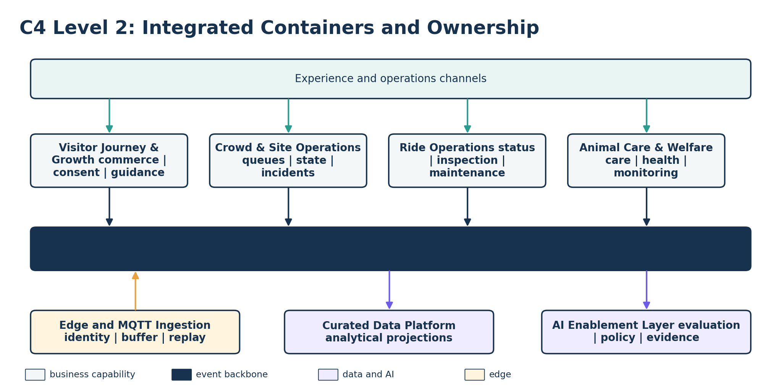
Figure 2. Integrated C4 Level 2 view. Domain containers remain authoritative; shared services provide transport, analytics and governed AI.

Domain ownership
Capability | Owns | Key events
Visitor Journey & Growth | Accounts, consent, products, orders, passes and preferences | Purchase completed; entry validated; recommendation outcome
Crowd & Site Operations | Queue estimates, site state, incidents, tasks and public guidance | Queue updated; congestion detected; guidance approved
Ride Operations | Ride status, inspections, defects, maintenance and return-to-service evidence | Ride status changed; defect recorded; maintenance completed
Animal Care & Welfare | Animal, feeding, health, husbandry, population and welfare workflows | Welfare alert raised; care task completed; restriction approved

Event semantics and consistency
- Assume at-least-once delivery. Consumers must be idempotent and deduplicate using event identifiers.
- Ordering is scoped to an aggregate such as a ride, enclosure, pass or incident, not across the entire estate.
- Domain transactions publish events through a reliable outbox or equivalent atomic publication mechanism.
- Contracts are versioned and compatibility-tested; breaking changes require a new version and a controlled migration.
- Late and stale observations retain event time, received time, quality and freshness metadata.
- Dead-letter handling and replay require an authorised operator, an audit record and protection against historical events triggering current actions.

3. Deployment, connectivity and resilience
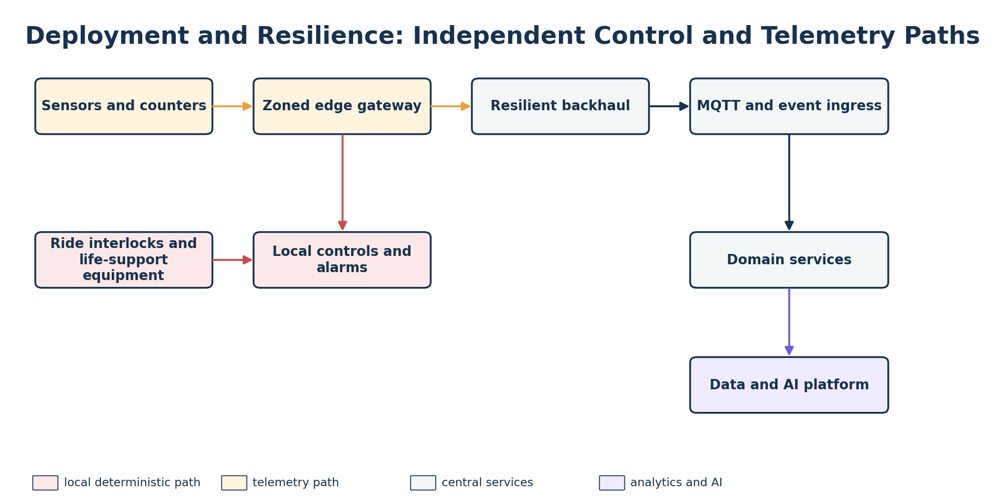
Figure 3. The deterministic safety and welfare path is separated from the telemetry and analytical path.
Zoned, mains-powered gateways provide device identity, validation, durable buffering and replay. Routine telemetry can wait for restored backhaul. Critical thresholds raise local alarms immediately. Cloud and AI services receive evidence and operational state but never sit in the immediate control path.
Failure scenario | Designed behaviour | Verification
Backhaul unavailable | Buffer observations, mark freshness and replay after reconnection | Simulated 24-hour outage and reconciliation
Gateway unavailable | Other zones continue; create a device-health incident | Fault-isolation exercise
Central region unavailable | Critical local operations continue; recover central services from replicated data and event positions | Recovery exercise against proposed service tier
AI unavailable or suspended | Use deterministic rules, inspections and approved default content | Workflow fallback test
Stale data | Withdraw or visibly label estimates; block unsafe recommendations | Automated freshness-policy test
Data corruption | Restore authoritative data and reconcile projections and event positions | Backup and restore verification

Proposed continuity tiers
Tier | Examples | Continuity principle
A: local critical | Ride safety controls; enclosure life-support alarms | Independent of cloud and AI; local procedures remain authoritative
B: operational | Entry validation; ride and welfare workflows; site incidents | Bounded degraded mode; proposed RTO/RPO agreed during discovery
C: analytical | Historical reporting; forecasting; personalisation | Can pause and recover without affecting immediate safety

4. AI value, governance and validation
AI is applied only where outputs can be evaluated and failure cannot bypass deterministic controls. Conventional ML, time-series methods or computer vision are preferred for bounded detection and forecasting. Generative AI is limited to cited retrieval, summarisation and conversational assistance over approved information.
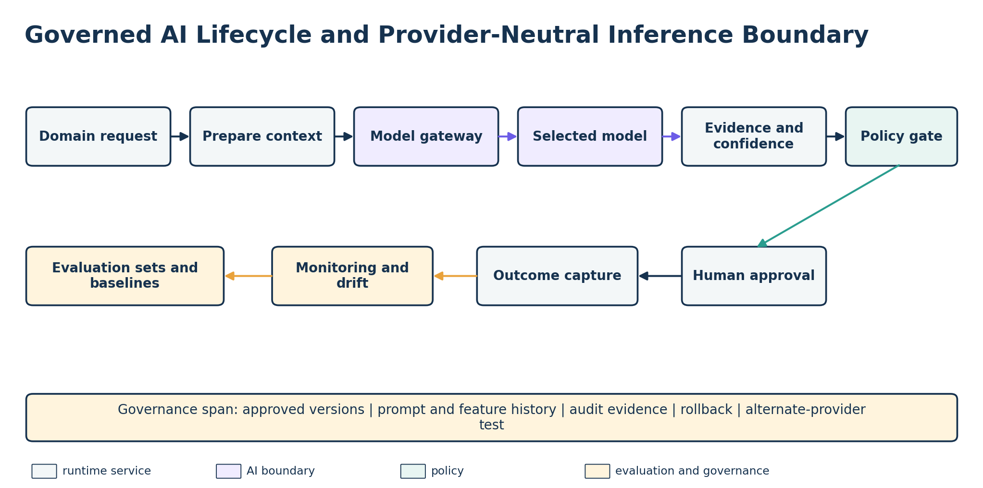
Figure 4. Provider-neutral inference, policy enforcement, human accountability and outcome feedback form one governed lifecycle.

AI value map and non-AI baselines
Use case | Non-AI baseline | AI contribution | Promotion evidence
Queue and demand forecasting | Current counts, throughput calculation and thresholds | Short-horizon forecast and option ranking | Lower error at a useful horizon plus operator value
Ride maintenance risk | Inspections and preventive schedule | Anomaly and risk indication | Earlier actionable warnings without unacceptable alert load
Animal-health indication | Local thresholds and scheduled care | Multivariate anomaly and selected vision | Earlier detection within approved missed-event and false-alert bounds
Visitor recommendations | Popular, available editorial content | Consent-aware ranking | Measured visitor benefit with zero policy violations
Staff knowledge assistant | Search and approved procedures | Cited retrieval and summarisation | Grounded-answer quality, citation validity and safe escalation
Cross-estate optimisation | Duty-manager dashboard and rules | Rank operational options across queues, availability and staffing | Human-approved trials improve agreed flow metrics without safety-policy breaches
Animal visibility forecasting | Observed reader state, keeper status, published schedules and species activity patterns | Predicted next visible window for an enclosure that is currently empty | Beats the schedule-and-pattern baseline on observed-visibility hit rate, with zero policy-filter breaches

Non-negotiable guardrails
- AI cannot control or override ride interlocks, life-support equipment, local alarms or emergency procedures.
- AI cannot diagnose animals, prescribe treatment, certify ride safety, approve maintenance or return a ride to service.
- AI cannot alter tickets, passes, prices, refunds, consent or communication permissions.
- Consequential recommendations must include evidence, confidence, model and policy versions, supported operating conditions and an audit identifier.
- Models may be paused or rolled back independently of domain workflows.

Lifecycle and cold-start strategy
Stage | Control and evidence
Bootstrap | Capture trustworthy operational data; establish deterministic baselines and data-quality ownership
Shadow | Run models without affecting decisions; compare with human decisions and actual outcomes
Advisory release | Evaluation set, baseline comparison, policy tests, owner approval and documented operating conditions
Runtime | Input-quality checks, policy enforcement, evidence, latency and cost telemetry, safe fallback
Production | Drift, false alerts, missed-event reviews, override analysis, consent and safety violations, business outcomes
Change or exit | Shadow or canary comparison, compatibility suite, rollback and alternate-provider rehearsal

5. Critical operational journeys
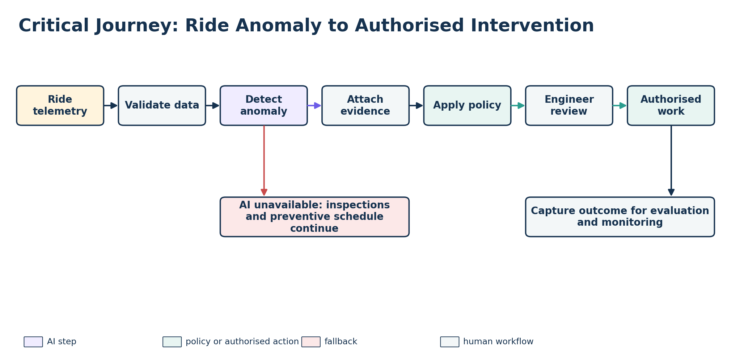
Figure 5. Ride anomaly to authorised intervention. AI recommends; an engineer authorises work and return-to-service remains a controlled process.
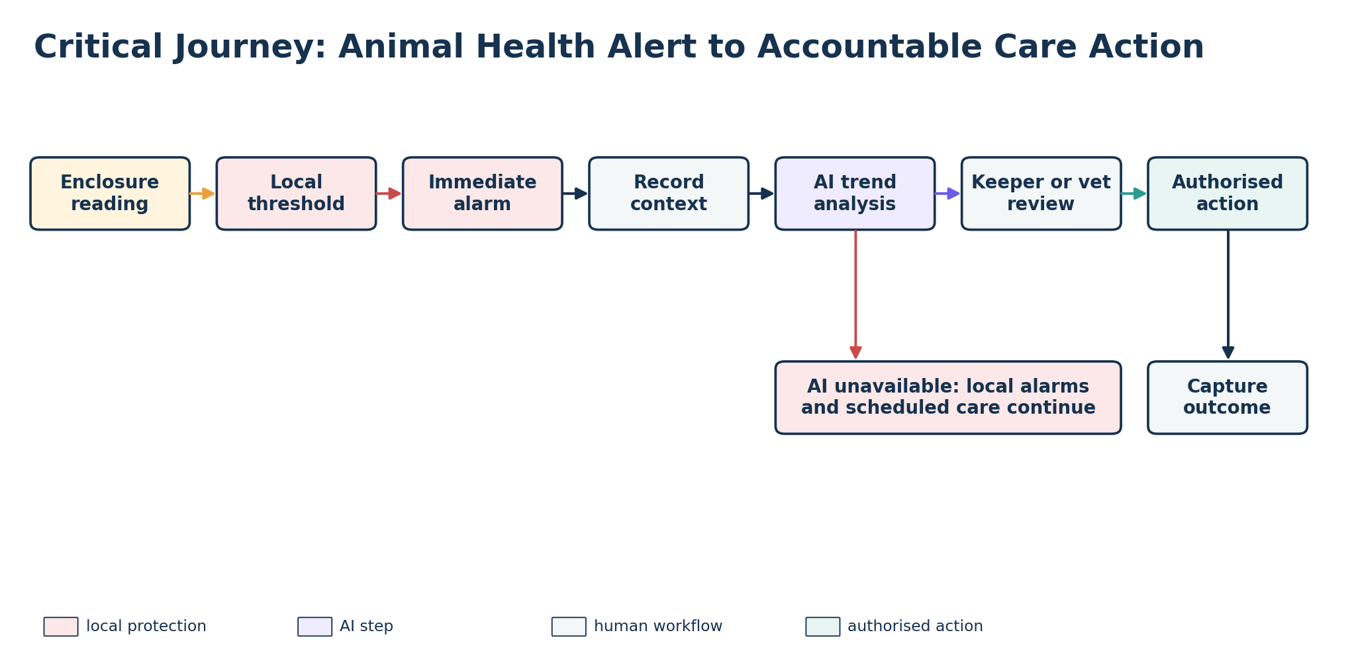
Figure 6. Animal-health alert to accountable action. The immediate local alarm is independent of cloud AI.

Animal identity, population and visibility
Population and visibility are two business questions answered by one sensing investment. Exotic collections are routinely microchipped to ISO 11784/11785 for identification and licensing — the same standard as the PIT tags used in aquatic displays. Where those chips already exist the estate installs readers rather than tags, and the welfare cost approaches zero. Confirm during discovery.
The jumping piranha collection cannot be ground-truthed: no label exists, so a model reporting an exact count can be neither confirmed nor falsified. Three independent estimators are therefore combined — continuous PIT detections at a feed antenna, which identify marked fish; a daily vision count over the feed window, which sees all fish but is biased low by occlusion; and a quarterly manual count, the only exact observation. A mark-recapture estimator publishes a range with confidence, never an integer.
This is the estate's worked example of validating AI where no labels exist. Each manual count retrospectively scores every estimate published since the previous one, and the headline metric is calibrated coverage — whether a 95% interval contains the truth 95% of the time — rather than accuracy. Between counts the sources police each other: if vision sees fewer marked fish than the antennas read in the same window, vision is under-counting today. The deterministic baseline needs no AI — an individual tag unseen beyond its window raises a keeper task from a rule at the gateway.
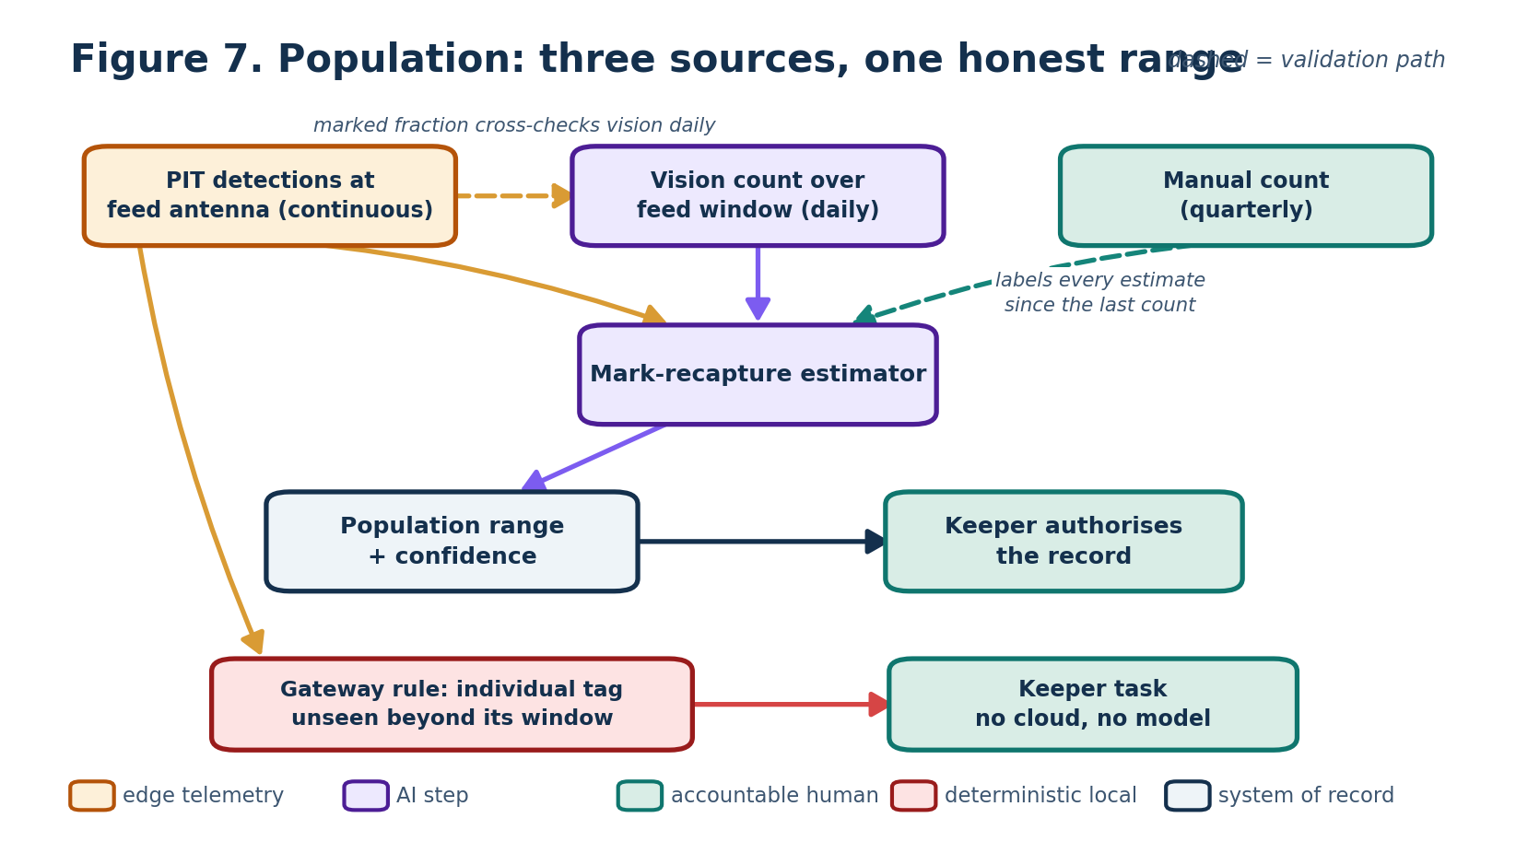
Figure 7. Three independent sources produce one range with confidence. The manual count labels every estimate since the previous count; the deterministic absence rule runs at the gateway without cloud or model.
Sited at a den entrance rather than a feed station, two readers in sequence resolve direction of travel and yield an occupancy state machine. Published to visitors, this removes the most common disappointment in an animal collection, spreads crowds away from congestion, and separates “unpopular” from “empty when people arrived” — a distinction that changes where the estate invests. A tag reports presence, not consciousness: resting is inferred from keeper status, schedules and species activity pattern, and only the forecast of the next visible window requires a model.
State | Determined by | Treatment
ON_SHOW | Direction-resolved passage outward | High confidence
OFF_SHOW | Direction-resolved passage inward | High confidence
LIKELY_RESTING | Species activity pattern, time of day, no recent passage | Medium; labelled as inferred
KEEPER_SET | Keeper override, any value | Authoritative; always wins
UNKNOWN | Reader fault or stale data | Published as unknown, never inferred as off show

Two guardrails follow:
- Reader silence publishes UNKNOWN and never OFF_SHOW; a failed reader and an animal in its den are indistinguishable to the sensor and entirely different to a visitor at the glass. Species carrying theft or release risk publish coarse location or none.
- Animal Care owns visibility and may suppress publication unilaterally; visitor channels consume a sanitised projection and cannot write back. Publication is damped by hysteresis, staggered notification and suppression for an enclosure already at its occupancy threshold, so the feature does not create the congestion it exists to relieve.
Visibility prediction is the estate's clearest candidate for bounded autonomous action: the worst outcome is the status quo, it is reversible within minutes, it scores itself continuously against observed reader state with no human labelling, and post-model policy filters prevent it contradicting an observation, closure or keeper override. It therefore publishes without per-instance approval while auto-suspending on an accuracy breach — autonomy calibrated to consequence rather than blanket prohibition.
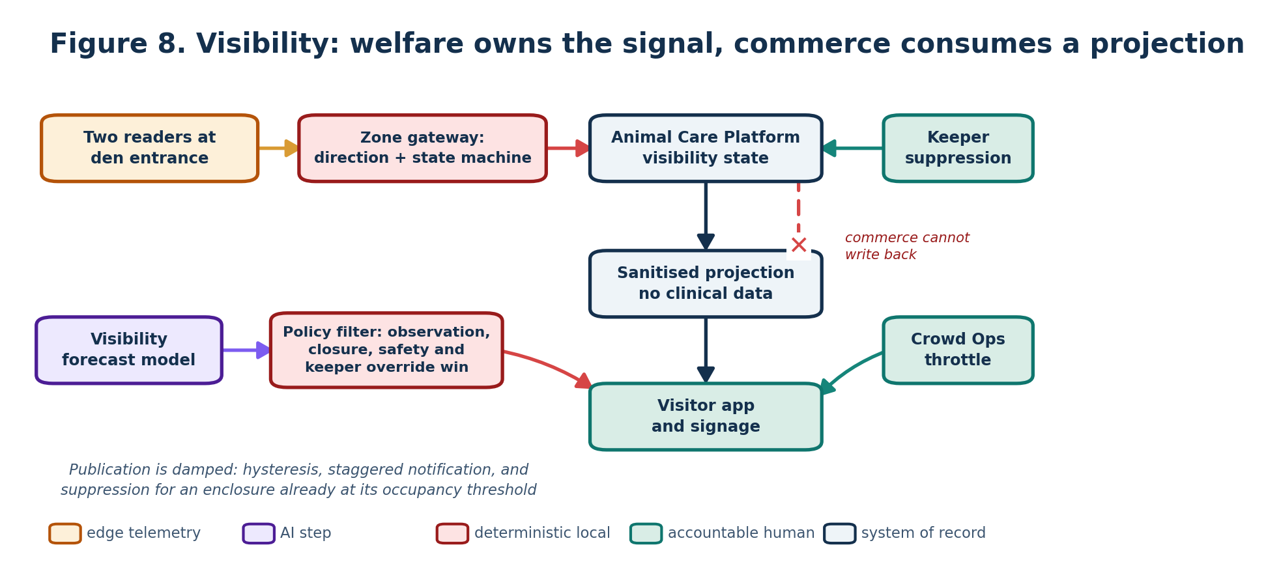
Figure 8. Animal Care owns visibility state and may suppress publication; visitor channels consume a sanitised projection and cannot write back. Policy filters apply after the model.

Regulatory context
Animal records are a regulated artefact. Zoo licensing requires an accurate stocktake and supports periodic inspection, and association accreditation adds record-keeping and breeding-programme obligations. Two consequences follow. The authoritative animal record is the accredited sector system; the Animal Care Platform is a system of engagement over it, reconciling rather than competing. And a regulatory return cannot be a model output — the figure submitted to a regulator or studbook is a human-authored count with named authorisation and an audit trail, which is the independent reason ADR-10 keeps AI out of the recorded number.

6. Security, privacy and threat model
Security is treated as an architectural characteristic across devices, gateways, APIs, events, data and AI. Controls are risk-based and preserve separation between visitor, operational, ride and veterinary information.
Area | Required controls
Device and gateway trust | Unique device identity, certificate rotation and revocation, signed updates, health and tamper signals. Every device, user, workload and retrieval source is explicitly authorised.
MQTT and events | Encrypted transport, topic-level authorisation, rate limits, schema validation, idempotency, dead-letter and replay governance.
Identity and access | Least privilege with separate visitor, operations, engineering and veterinary scopes; privileged-access review.
Data protection | Classification, encryption, minimisation, owned retention, auditability and controlled analytical projections.
AI and retrieval | Approved-source allow-list, content provenance, prompt-injection tests, output policy enforcement and model supply-chain controls.
Operations | Central observability, alert ownership, incident playbooks, backup and restore tests, secrets and key management.

Priority threat scenarios
Threat | Impact | Primary mitigation | Evidence
Compromised sensor publishes false readings | Incorrect queues, alerts or model inputs | Device identity, schema/range checks, corroboration and quality rating | Attack simulation and anomaly logs
Cloned device publishes to MQTT topics | Fraudulent telemetry and event flooding | Mutual authentication, topic ACLs, revocation and rate limits | Certificate-revocation exercise
Malicious document influences staff assistant | Unsafe or unsupported guidance | Approved corpus, provenance, retrieval isolation, prompt-injection tests and citations | Adversarial evaluation suite
Unauthorised access to ride or veterinary records | Safety, welfare and privacy exposure | Least privilege, segregated roles, strong authentication and audit review | Access-control tests and audit sampling
Replay or delayed event triggers current action | Incorrect operational response | Event-time and freshness policy, idempotency, replay approval and command validation | Controlled replay test
Live animal location published publicly aids theft or release | Loss of a rare or dangerous animal; welfare, safety and licensing exposure | Species risk classification; coarse or suppressed publication for flagged species; no public movement history; rate limiting | Risk classification review; public-contract test

Data lifecycle
Data class | Owner and treatment
Commercial and consent | Visitor domain; auditable history, restricted access and validated retention
Anonymous crowd telemetry | Crowd domain; aggregate where possible and delete raw data when no longer operationally useful
Ride inspection and maintenance | Ride domain; preserve authorised engineering evidence and change history
Animal health and welfare | Animal-care domain; restricted clinical and husbandry access with controlled minimum-data projections
Raw sensor telemetry | Owning operational domain; quality, retention and aggregation proportional to diagnostic and model need
AI evidence | AI/platform owner with domain accountability; retain model, prompt/feature, policy, source and outcome versions
Regulated animal records | Animal-care domain, reconciled to the accredited sector record; retention set by licensing and accreditation rather than by the estate; human authorship and audit trail required

7. Architectural decision records

ADR-01: Domain-owned systems of record
Status | Decision | Consequences | Rejected alternative | Enforcement / review
Proposed | Use four domain-aligned platforms, each authoritative for its records. | Clear accountability; requires governed integration. | Central enterprise monolith. | Enforce ownership in APIs, schemas and access reviews.

ADR-02: Event-driven estate integration
Status | Decision | Consequences | Rejected alternative | Enforcement / review
Proposed | Exchange curated, versioned facts through the Estate Event Platform. | Loose coupling and replay; eventual consistency. | Point-to-point database integration. | Contract and idempotency tests; controlled replay policy.

ADR-03: Edge-first MQTT ingestion
Status | Decision | Consequences | Rejected alternative | Enforcement / review
Proposed | Use zoned gateways with identity, validation, buffering, replay and local thresholds. | Outage resilience; adds fleet management and reconciliation. | Every device publishes directly to cloud. | Quarterly outage tests and device-health SLO.

ADR-04: Deterministic control remains local
Status | Decision | Consequences | Rejected alternative | Enforcement / review
Proposed | Keep ride interlocks, life-support alarms and bounded entry validation local. | Strong independence; limits remote automation. | Cloud-controlled operational protection. | Architecture test prohibits cloud or AI dependencies in critical paths.

ADR-05: AI is advisory and evidence-backed
Status | Decision | Consequences | Rejected alternative | Enforcement / review
Proposed | Require evidence, policy filtering and accountable approval for consequential outcomes. | Lower autonomy; better safety and auditability. | Autonomous operational action. | Schema and workflow controls; risk acceptance required for any expansion.

ADR-06: Provider-neutral AI boundary
Status | Decision | Consequences | Rejected alternative | Enforcement / review
Proposed | Use versioned internal inference contracts and retain evaluation assets independently. | Portability; compatibility effort. | Provider-specific logic embedded in domains. | Annual replacement and cost rehearsal.

ADR-07: Privacy-minimised sensing and consent
Status | Decision | Consequences | Rejected alternative | Enforcement / review
Proposed | Use anonymous counts by default and centralise consent decisions. | Reduced privacy risk; less individual tracking. | Persistent individual location tracking. | Contract tests and recurring privacy review.

ADR-08: Curated analytics, not a second truth
Status | Decision | Consequences | Rejected alternative | Enforcement / review
Proposed | Build analytical projections from events; commands return to owning domains. | Cross-estate insight; eventual consistency. | Shared operational database. | Freshness and reconciliation checks.

ADR-09: APIs for commands; events for facts
Status | Decision | Consequences | Rejected alternative | Enforcement / review
Proposed | Use authenticated APIs for immediate commands and events for completed business facts. | Clear intent and consistency boundaries; two integration modes. | Everything as events or direct database calls. | API/event naming and architecture tests.

ADR-10: Animal records are human-authored and reconciled to the accredited record
Status | Decision | Consequences | Rejected alternative | Enforcement / review
Proposed | Publish population as a range with confidence, method and inputs for operational use. The recorded figure, and any regulatory or studbook return, is human-authored. Treat the accredited sector record (ZIMS) as authoritative for regulated animal data; the Animal Care Platform owns workflow, telemetry and evidence and reconciles to it. | Honest uncertainty operationally and a defensible regulated record; adds reconciliation effort and a dependency on an external system. | A single integer produced by the vision model; or making the estate platform the authoritative regulated record. | Schema rejects population events lacking interval, method and inputs; contract test asserts no regulated field is model-written; reconciliation exception report at each stocktake.

ADR-11: Welfare owns visibility; prediction is bounded-autonomous
Status | Decision | Consequences | Rejected alternative | Enforcement / review
Proposed | Animal Care owns visibility state and may suppress publication unilaterally. Visitor Journey consumes a sanitised, read-only projection. Predicted visible windows publish without per-instance approval, bounded by post-model policy filters. | Commercial incentive cannot reach the welfare signal; demonstrates autonomy calibrated to consequence; requires reliable automatic suspension. | Visitor platform reads animal records directly; or human approval for every prediction. | Contract test asserts no clinical field crosses the boundary; an accuracy breach auto-suspends publication.

8. Traceability and headline fitness functions
Requirement | Architecture response | ADRs | Headline evidence
Ticketing and family passes | Visitor commerce and offline signed entitlement validation | 01, 04, 07, 09 | Purchase SLO; entry reconciliation; offline exercise
Understand popularity | Anonymous sensing, queue estimation and curated analytics | 02, 03, 07, 08 | Queue accuracy, freshness and privacy contract tests
Animal health, feeding and population | Care record, husbandry workflow, local alerts and advisory AI | 01, 03, 04, 05, 10 | Alert latency; mandatory care; AI evidence
Grow visitors and profitability | Consent-led journey, recommendation and controlled experiments | 05, 06, 07, 08 | Policy compliance; repeat-visit and referral uplift
Patchy Wi-Fi and cloud transfer | Zoned gateways, MQTT ingress and durable replay | 02, 03 | 24-hour outage and device-health exercises
Ride reliability and popularity | Inspection, maintenance, status and predictive recommendation | 01, 02, 04, 05 | Inspection compliance; downtime; lead time
AI innovation and uncertainty | Model gateway, evaluation, monitoring, evidence and fallback | 05, 06 | Baseline uplift; drift controls; provider replacement
Animal population levels (jumping piranhas) | Chokepoint identity telemetry, vision count at feed and mark-recapture estimator with a human-authored record | 01, 03, 05, 10 | Interval calibration at each manual count
Visitor growth through animal visibility | Welfare-owned visibility state, sanitised visitor projection and bounded autonomous prediction | 05, 07, 08, 11 | Visibility honesty drill; prediction scoring
Licensing, accreditation and inspection | Accredited record as authoritative, human-authored regulated figures, reconciliation and full audit history | 01, 04, 10 | Stocktake reconciliation; inspection evidence sampling

Headline architecture fitness functions
ID | Fitness function | Proposed success measure | Evidence
FF-01 | Purchase and entry | Agreed purchase SLO; every admitted entry maps to a valid entitlement or approved exception | SLO dashboard and reconciliation
FF-02 | Offline entry | Signed validation continues for the agreed outage window | Resilience exercise
FF-03 | Queue quality | Estimate error remains within calibrated threshold; stale estimates are withdrawn or labelled | Manual comparison and policy test
FF-04 | Critical welfare alert | At least 99.9% raised locally within 30 seconds of a confirmed breach | Gateway simulation
FF-05 | Telemetry durability | Less than 0.1% loss during simulated 24-hour backhaul outage | Quarterly resilience test
FF-06 | Ride inspection | 100% of mandatory checks complete or the ride remains unavailable | Workflow control
FF-07 | Unplanned ride downtime | 30% reduction from an agreed baseline | Monthly reliability review
FF-08 | AI evidence and policy | 100% of consequential recommendations include evidence and versions and pass current policy | Runtime schema and policy tests
FF-09 | Model health | Models assessed on agreed cadence; breach creates an owned review task and can suspend inference | MLOps control
FF-10 | Provider replaceability | Evaluation suite passes through an alternate provider or model adapter | Replacement rehearsal
FF-11 | Population interval calibration | Published 95% intervals contain the manual count in at least 90% of manual-count events, over a rolling eight-count window | Manual count reconciliation
FF-12 | Visibility honesty | 100% of reader faults publish UNKNOWN and none publish OFF_SHOW; keeper suppression applies across all visitor channels within 60 seconds | Fault-injection and suppression drill
FF-13 | Bounded autonomy | Visibility predictions beat the schedule-and-pattern baseline; a breach automatically suspends publication and raises an owned task | Continuous scoring against observed reader state

9. Delivery, cost, value and ownership
Phase | Scope and dependency | Business value | Primary cost / risk
1. Foundations | Ticketing, passes, consent, registers, workflows, identity, event backbone and observability | Reliable commerce and authoritative operational records | Integration, migration, data quality and change adoption
2. Resilient operations | Priority sensors, gateways, local alarms, replay, site state and queue estimates | Visibility through outages and stronger ride and welfare operations | Hardware, installation, connectivity and calibration
3. Governed intelligence | Curated data products, shadow models, evaluation, policy, evidence and drift controls | Earlier intervention and more relevant guidance | Labelled data, inference, evaluation and operational adoption
4. Estate optimisation | Cross-domain options, workforce analytics, growth experiments and replacement exercises | Measured profitability, repeat visits and estate-wide coordination | Benefits uncertainty and continued model/provider cost

Value gates
Sensing expands only where data capture is reliable and owned; AI is promoted from shadow to advisory only when it beats the agreed non-AI baseline and passes safety and policy tests; personalisation scales only once consent enforcement and controlled experiments show value. Models can always be suspended, reverted to deterministic behaviour, or moved to another provider without redesigning domain workflows.

Operational accountability
Area | Business owner | Operational responder | Technical / model owner | Decision authority
Visitor commerce and consent | Commercial product owner | Guest services / commercial operations | Visitor platform owner | Commercial and privacy owners
Crowd and public guidance | Duty manager | Site operations | Crowd platform and model owner | Duty manager
Ride maintenance | Head of ride engineering | Authorised ride engineer | Ride platform and model owner | Authorised engineer
Animal welfare | Head keeper / veterinary lead | Keeper and veterinary staff | Animal-care platform and model owner | Qualified keeper or vet
Edge and shared platform | Estate technology owner | Platform operations | Platform, security and data owners | Service and risk owners

10. Key risks, inclusion and conclusion
Risk | Mitigation and evidence
Poor sensor quality or calibration | Quality-rated observations, calibration programme, manual comparison and device-health incidents
Connectivity disruption | Local controls, buffering, replay, stale-data policy and outage exercises
AI drift or unsupported conclusions | Operating conditions, evidence, monitoring, human approval, suspension and fallback
Privacy or consent failure | Anonymous counts, minimised features, central consent and automated policy audits
Domain data duplication | Authoritative ownership, curated projections, reconciliation and freshness metadata
Provider lock-in or cost change | Internal contracts, usage telemetry, alternate-provider tests and phased investment
Operational adoption failure | Workflow co-design, named owners, training, override feedback and value gates
Brownfield ride limitations | Telemetry feasibility assessment, non-invasive sensing, engineering approval and no change to certified controls
Divergence between the estate platform and the accredited animal record | Single authoritative regulated record, scheduled reconciliation, exception reporting at stocktake, and no model-written regulated fields

Accessibility and inclusive experience
Visitor channels meet agreed accessibility standards and retain a usable non-smartphone route through kiosks, signage and staff; guidance applies current accessibility, closure and safety metadata after model output, never infers sensitive traits, and remains usable on a poor connection.
FINAL POSITION The proposal is an argument for measurable estate outcomes, not a catalogue of technology. It combines clear domain ownership, resilient edge collection, event-driven coordination and bounded AI. Irreversible safety, welfare, consent and commercial decisions remain with deterministic controls and accountable people, while models, providers and deployment choices remain evolvable.

Glossary
Term | Meaning
C4 | Context, Container, Component and Code views for communicating software architecture
MQTT | Lightweight publish/subscribe protocol used here for estate telemetry transport
System of record | Authoritative source for a defined class of operational information
Curated event | Versioned, minimum-necessary business or operational fact
Fitness function | Measurable test or control that continuously checks an architectural characteristic
Human in the loop | Accountable person reviews or authorises a consequential outcome
PIT tag | Passive integrated transponder: a batteryless ISO 11784/11785 microchip read at close range; the same standard as veterinary identification chips
ZIMS | Zoological Information Management System (Species360): the sector-standard animal record used by accredited collections
EAZA / BIAZA | European, and British and Irish, zoo and aquarium associations whose accreditation sets record-keeping and breeding-programme standards

Source basis: Architecture Kata 2026 brief; Architecture Kata Judging Rubric Summary; Architecture Kata Submission Priorities; Submission Output; Prompts Output; and the four detailed capability submissions supplied for review.

